Tutorial: How to produce a map visualization in Tableau.

**Choosing a topic:**

To begin, we must first find a compelling topic to analyze and it must be spatial in nature. I chose the topic of deaths by drunk driving versus gunshots. This is a somewhat interesting topic because gun deaths, in particular, are highly politicized. Depending on which side of the aisle you lean, there are many ways to present the data to support your argument. I am trying to avoid politics and ask the question, are you more likely the victim of a shooter or of a drunk driver? From a spatial perspective we have the option of looking at a national level (country by country), state by state, and possibly drill down as deep to the county or city level.

**Sourcing the data:**

We need to find two different data sets to answer our question. Data set one will be firearm murders, data set two will be drunk driving fatalities. These two data sets will need to be merged on our spatial dimension.

I think its common knowledge that the FBI is the gold standard for murder data. I therefore went to the FBI’s website to search for crime statistics. 2017 numbers have not been finalized yet, so I therefore went for 2016. Table 12 covers homicide by weapon type and allows us to easily download it in excel format. This portion of our data is good to go with the exception of murders for Alabama is clearly wrong (as only 3 murders are reported on this table) and this table is missing the state of Florida. For now, I am using null values for these two states.

For drunk driving I pulled data from the department of transportation. Again, this is the leading authority for this kind of data. I try to stick to government agencies whenever possible, because we know that we can trust their information. I managed to find a pdf that contained the table I was seeking, but this required a little more effort. When copying the data out, it all pasted out into one line in excel. This would require quite a bit of effort to become readable in tableau. ( Simply using text to column with a space delimiter is not enough). I therefore saved the 2016 numbers to a text document (ignoring the wonky headers) , imported into R and had R read the text file and transform into a table with a space delimiter. Then I simply had R write the table into a CSV, added back the headers, and after merging this table with the murders based on state I was ready to import everything into Tableau.

**R code:**

data <- read.table("alcoholcrashes.txt", sep = "" , header = F)

write.csv(data, file = "alcohol.csv", row.names = FALSE)

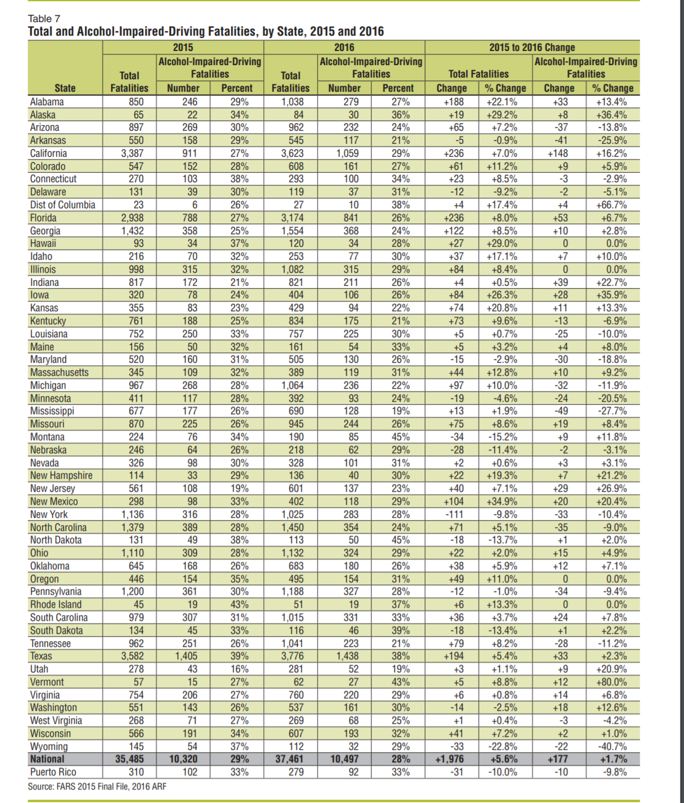

**Creating the map in Tableau:**

For those new to Tableau, its all rather user friendly… for the most part. Tableau makes it easy to import data and as long as its structured and labeled it recognize the data types (i.e numeric, continuous, etc.) Without much or any manual imput. Rather than having to program, you can simply click and drag your features around to declare your dependent and independent variables. From there you can choose how Tableau will visualize it.

For creating a map, all we need to do is provide accurate geographic information. From our data set we have state names which are all that we need for Tableau to works its magic and create a map of the United States with which to visualize our data. The challenge is knowing which specific variables we want to present on the map and how we actually want these features to be visualized.

In this example, I very specifically chose fatal shooting victims versus dui victims. To visualize this, I needed to create my own metric. Because my question is simply a binary one( Are murders higher or are duis higher in this state?) I decided on a simple ratio. After creating this ratio, we simply click and drag it over to “measures” and assign it to colors where we can set our schema. If the ratio of dui to shooting is over 1:1 we can color it red, if not then it’s blue. If its exactly 1:1 it will be colored white and the close we get to be even the lighter the color. This color scheme is simple and easy to read. You can understand what is happening in it with a simple glance.

Data sources:

<https://ucr.fbi.gov/crime-in-the-u.s/2016/crime-in-the-u.s.-2016/tables/table-12> (missing florida)

2016 Fatal Motor Vehicle Crashes: Overview www-nrd.nhtsa.dot.gov/CATS/index.aspx